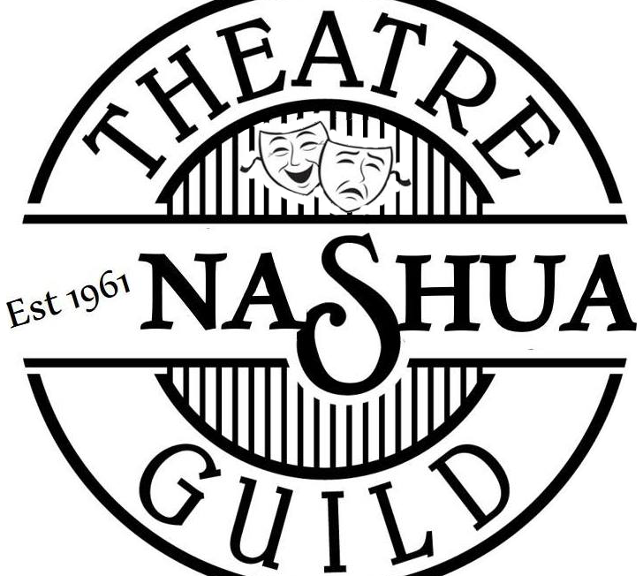
Director:

Phone # (Do you prefer text):

Email:

Title Of Show:

Playwright:

Publisher:

Royalty Fees per show:

Length of Play:

Cast /Age Range:

Cast Breakdown:

Preferred Stage Manager:
Contact Info:

Have you done a show in Court Street Theatre?

Your Concept of the Production (mood, setting, tone, production design, etc.:

Target Audience:

Other considerations (strong language, content, etc.) If so, how do you propose to handle it?

Have you seen this produced before?

Why would you like to direct this play?

Technical Requirements
Set. Describe the set for this play. How many scene changes? Are there any aspects of the set that may be challenging or expensive to construct? What solutions do you envision?

Costumes. What period is your play set? Are many costume changes required? Are there any challenges or specialty costumes involved?

Props. Can most of the props be easily obtained? Are any props particularly challenging or expensive to find or build?

Lights and Special Effects. What kind of lighting is required? Are spotlights used? Are there any special effects that must be developed?

Other. Are there any other production challenges you foresee? If so, please address them here.

How would you market this production?

Estimate of requested budget breakdown:

Rights: $
Lights: $
Sets: $
Costumes: $
Props: $
Marketing $

Total: $

